**Status bar (on the left)**

Include these headers mentioned below:

**Home  
About DESE (And on right side there would images sweeping in)  
Research   
Demos  
Events  
Schedule  
Golden Jubilee  
Sponsors  
Locate us  
Open day team**

|This is the Logo of our open day. We’ll send you the svg of all logos etc.  


The background image should be similar to the brochure (will share)

This is the theme for background

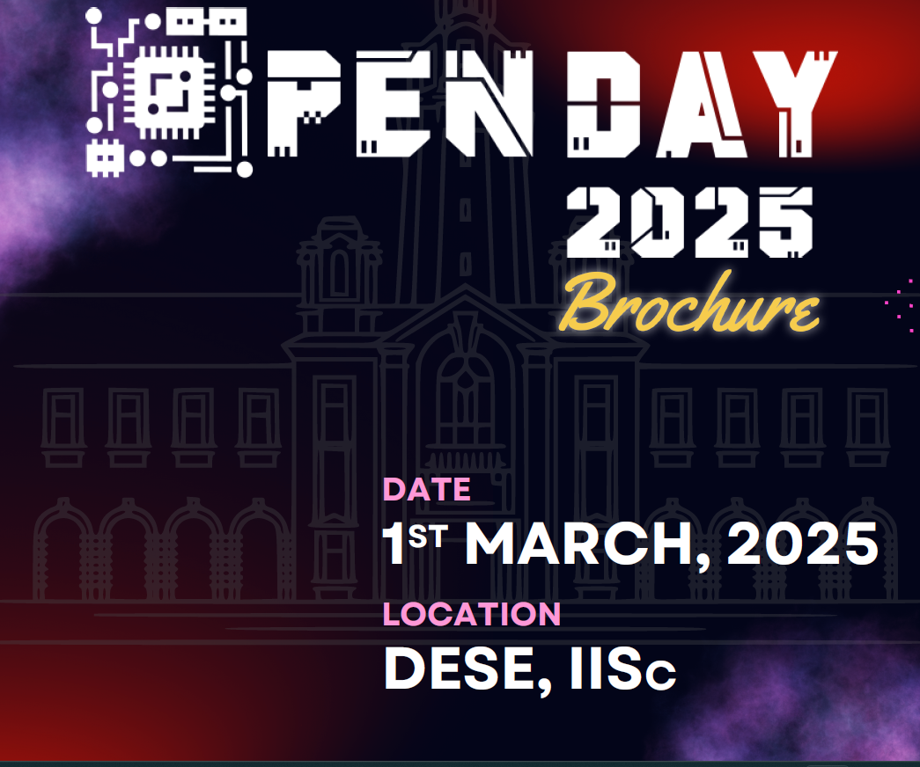

**About DESE** (And on right side there would images sweeping in like left to right)  
Some content on left and sweeping images on right.

CONTENT in ABOUT DESE:

The Department of Electronic Systems Engineering

(DESE), formerly CEDT, was established in 1974 with

a vision to achieve excellence in research and

education in electronic systems engineering while

making a positive societal impact. The department

focuses on training engineers and fostering

collaboration with the electronics industry in India.

Eg. Like this

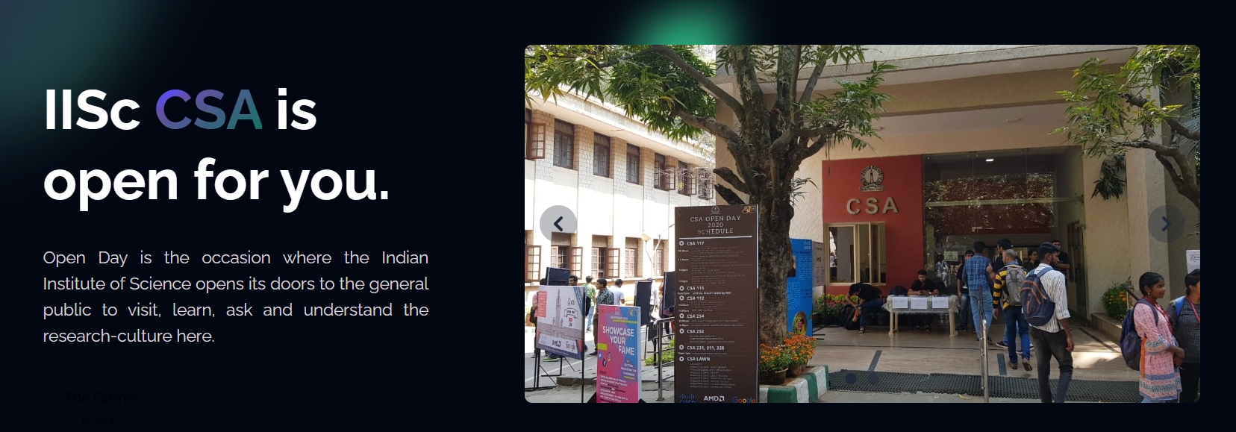

**Demos section:**Opens up a different page with 1 image + 3 line description of each demo project. Will have approx 30 demos. Eg.  
Will share you the content for demos page in 1-2 days.  
Just add one demo in this page. Just to add the theme should be same in all the pages.

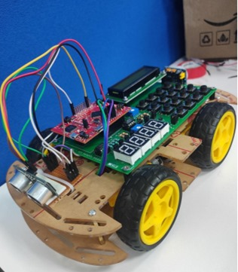

**Advanced Driver Assistance Systems (ADAS)**

ADAS is a cutting-edge technology designed to enhance vehicle safety and driving comfort. By using sensors, cameras, and intelligent algorithms, ADAS enables features like collision avoidance, lane-keeping assistance, adaptive cruise control, and pedestrian detection. It provides real-time monitoring and decision-making to assist drivers in critical situations. ADAS is a step toward autonomous driving, revolutionizing the future of transportation.

**Events**

1. It would have the LFR poster (find in folder)  
   Add some writeup like: (DESE) invites you to participate in the Line Follower Robot Contest—a perfect chance to showcase your robotics and technical skills!
2. Will update you guys of more posters of events, as of now only put one.

**Schedule (**Will update you the content**)**

**Research**

We’ll have 3 popups coming with fast transition.

**< (**you can find this in main dese website (links attached at last)

**Put this ‘Coming up’ thing also. Its on 1st march, so set it accordingly**

**Golden Jubilee**

This would open to a new page with content.  
<https://labs.dese.iisc.ac.in/openday/goldenjubilee/>

Content would be same just makeover. Add 50 DESE logo. SVGs all added

**‘Locate us’ section**

Reach us will have the map location: Check openday dese website for reference

**(**Put this beside the map like this**)**

**When**

1st March, 2025

**Where**

Department of Electronic Systems, INDIAN INSTITUTE OF SCIENCE, Mathikere, Bengaluru, Karnataka 560012

**How to get there**

IISc is often locally referred to as the Tata Institute. It is better to use the name Tata Institute with the taxi, auto-rickshaw drivers, and bus conductors. Inside the institute, we have enough banners for directions to reach our department DESE. (update this)

**A Note from the Chair**Will update you the content

**SPONSORS**Can it be made rolling left to right at the very end of website. For eg.  
We can also have social media handles like this in the below image.

📸 Instagram: <https://www.instagram.com/openday_dese_iisc/>

📱 Facebook: <https://www.facebook.com/share/14oVQcUGjD/>

💼 LinkedIn: <https://www.linkedin.com/company/dese-iisc>

**Sharing you the links of DESE for your reference:**

Open day page: <https://labs.dese.iisc.ac.in/openday/>

Golden jubilee: <https://labs.dese.iisc.ac.in/openday/goldenjubilee/>

CSA open day site: <https://events.csa.iisc.ac.in/openday2024/#sponsors>

Main DESE site: <https://dese.iisc.ac.in/>  
(Please take a reference of this site as well)

**Open day team**

Take reference from openday 25 DESE site. We’ll have similar to that.

Add ons: (AS of now don’t add them, will think and let you know)

Demo video   
<https://youtu.be/dy1AzVI7qAo>

Any help you need or for any questions, feel free to contact us.  
 **THANK YOU SO MUCH!  
WE REALLY APPRECIATE YOUR EFFORT! 😊**